

**SA2A to SA2A MKII – Upgrade Mod - 2017**

**You will need to buy the following parts**

**Transformers:**

1 Sowter 1149 input transformer – sideleads – [www.sowter.co.uk](http://www.sowter.co.uk)

1 Sowter 1010 output transformer – open frame – [www.sowter.co.uk](http://www.sowter.co.uk)

**Capacitors:**

1 Solen Fast 10uf – 630v output capacitor – [www.tubedepot.com](http://www.tubedepot.com)

1 Silver Mica Capacitor, 120pf – 630V – [www.mouser.com](http://www.mouser.com)

**Step 1)**

Replace Cinemag input transformer with Sowter 1449 input transformer on to the main PCB where you read ALT/IN/TRAFO

Solder the green wire to point number 1

Solder grey wire to point number 2 on the main PCB

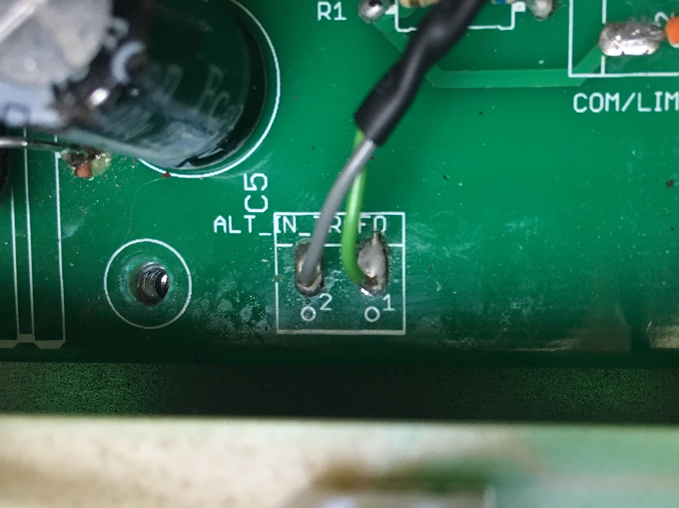

**Solder the remaining wires to the output XLR PCB (CZ1)**

White wire to pin 1

Red wire to pin 2

Blue wire to pin 3

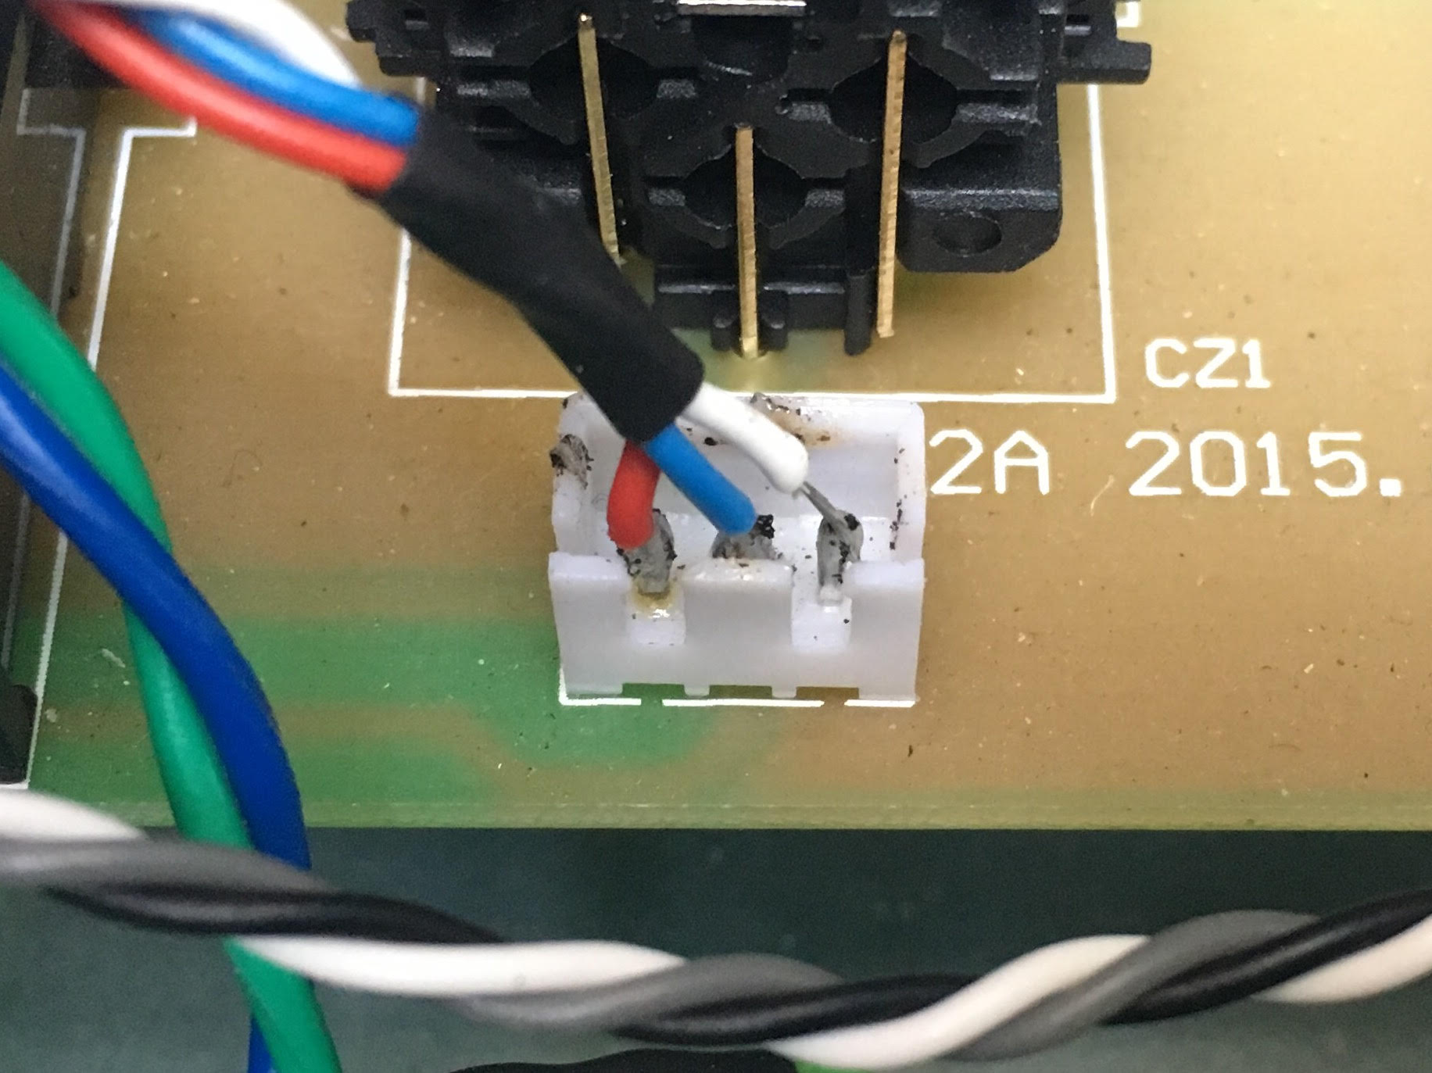

**Step 2)**

Replace the Cinemag output transformer for the Sowter 1010 output transformer

**Main PCB**

Solder the black wire to the output on the main PCB

**Output XLR PCB (CZ3)**

Solder the grey wire to pin number 2

Solder the white wire to pin number 3

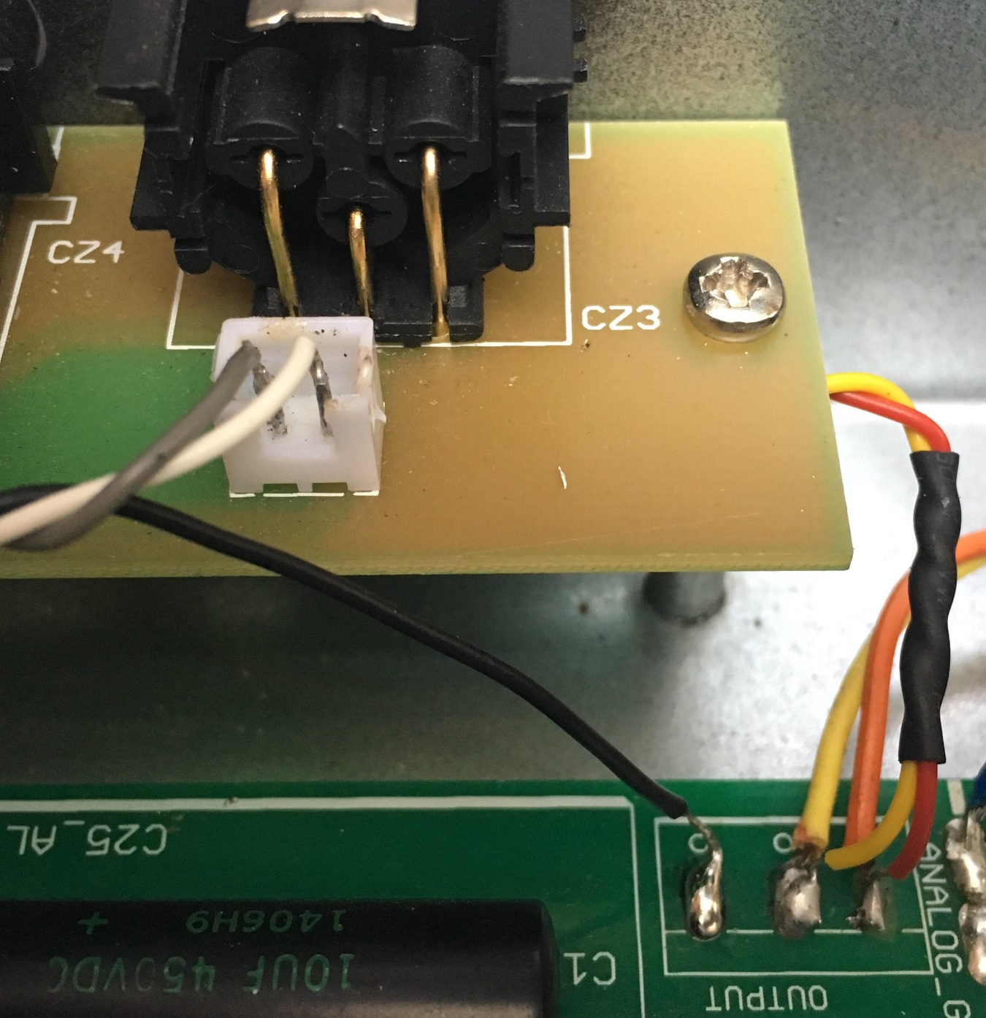

Step 3

Replace C25_ALT

Remove the Vishay Sprague output capacitor and solder the Solen Fast output capacitor

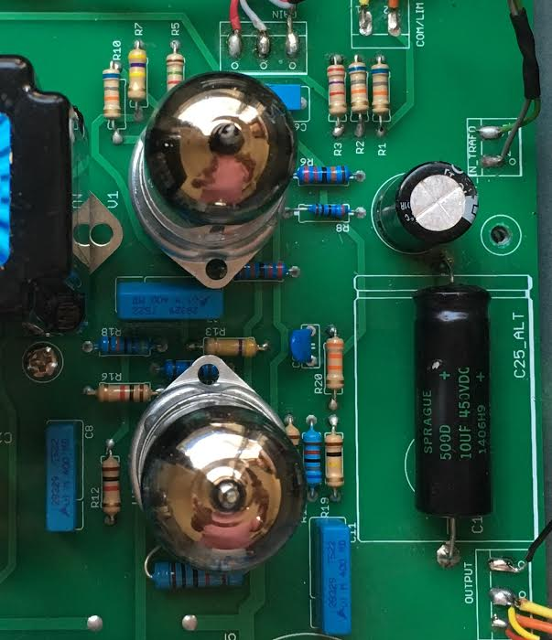

Step 4)

Remove C9 150pf – 500V capacitor

Solder the silver mica 270pf -500V onto C9.

Enjoy!

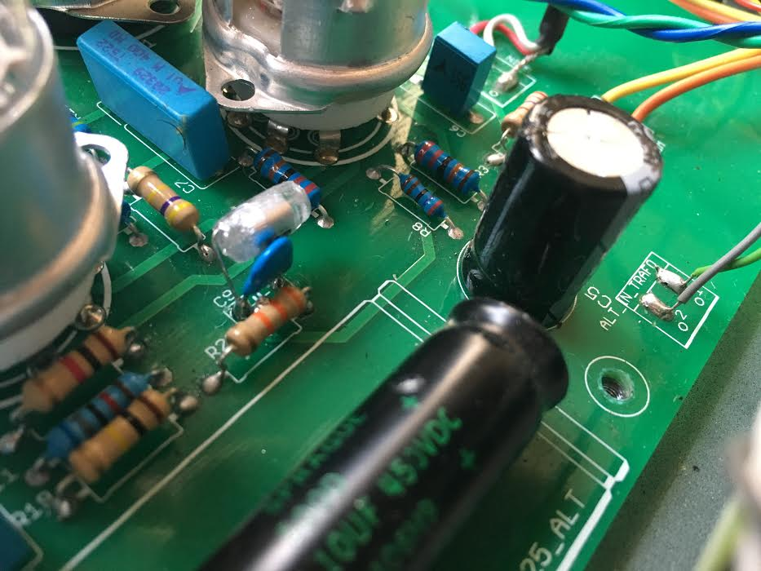

Step 5)

Calibration